You made very good efforts. However, please see my feedback with in the text.

Points: 41/50

Alejandro Garcia

6/11/2021

General Microbiology and Historical Perspectives
Microbiology is the study of biology, but on a significantly smaller scale. It is the “study of organisms too small to be seen without magnification” (Singh, 2021). These organisms include viruses, bacteria, algae, fungus, protozoa, and much more. It is important to note, however, that some of these organisms can be seen by the naked eye (such as colonies of fungi) but they are still studied by microbiologists. Why? It is because these cells are simple multicellular organisms in that they do not contain differentiated tissues. Thus, microscopic, single-celled organisms may live in a colony of cells, or independently. Today, microbiology consists of major fields such as medical microbiology, immunology, microbial ecology, industrial microbiology, and more. To understand how these fields got started, where they are now, and where they might be going, microbiology must be looked at from the very beginning (Singh, 2021).
Microorganisms have always been with us, but humanity did not know of their existence until about 1665 when Robert Hooke published Micrographia. Years later, Antonie van Leeuwenhoek observed microscopic living organisms in a patch of pond water. He called these tiny living things “animalcules” (Buchholz & Collins, 2013, p. 3748). Before Leeuwenhoek’s theories could be proven, humanity tried to explain and understand and manipulate disease.
(Opal. 2009). There are accounts from as Early as Ancient Egypt that document and attempt to explain the cause, spread, advantages, disadvantages of disease. As humanity searched for an answer, two major schools of thought cropped up. Girolamo Fracastoo’s “de Contagione” or the Germ Theory of Disease, sparked the Theory of Biogenesis - the idea that things can only come from other living things. The second was Spontaneous Regeneration: “Theory that life just ‘spontaneously’ developed from non-living matter” (Sing, 2021; Opal 2009, n.p.). Despite Leeuwenhoek and Hooke’s contributions on the subject (thereby promoting the Theory of Biogenesis), the theories of contagion still lacked scientific proof and would until Louis Pasteur’s work in the 1850s - nearly 200 years later (Opal. 2003, n.p.).
Additionally, Pasteur helped to solve the ongoing debate between the two schools of thought by illustrating that the process of fermentation was caused by microorganisms (yeast). He illustrated how these microorganisms could be inoculated into a new culture, what type of fermentation it caused, and the nutrients/chemicals required for growth. He also proved, through his “swan neck glass experiment,” that spoilage is caused by microorganisms (Buchholz & Collins, 2013, p. 3747-3748; Borresen, 2012, p. 134-135). These revelations, and more, made by Pasteur are what proved the germ theory right and sparked the beginning of the Golden Age of Microbiology.
Notably, Pasteur’s theories did not go unchallenged. From this work, developed what we now call “Pasteurization”. The pasteurization of milk products would go on to be a topic of debate for nearly a hundred years, especially during great spouts of Urbanization around the world which created questionable living conditions that strained milk production and transportation services (Obladen, 2014, p. 80). Besides, Pasteur’s work also inspired many researchers. Joseph Lister, in 1867, searched for a way to protect trauma patient’s wounds from infections. Through utilizing techniques, he observed on local farms, Lister demonstrated that by cleaning dressings, surgical equipment, and hands in a dilute solution of carbolic acid before surgery would drop the rate of infection post-operation. These sterile techniques were soon adopted on an international stage. Alongside Lister’s sterilization techniques came Robert Koch and Koch’s Postulates. At this time, debate still raged whether microorganisms could cause disease. By isolating the suspected bacterium, inoculating a healthy sheep with said bacterium, then isolating the newly formed bacterium from the sheep once it got sick, Koch essentially proved that disease has a microbial origin. He also discovered the Etiology of three important diseases: Cholera, Tuberculosis, and Anthrax. His assistants, Julius Richard Petri and Walter Hesse, would go on to develop plating methods, and agar, respectively (Opal, 2003, n.p.; Matthews et al., 2019, p. 7; Sing, 2021). Further on, Edward Jenner would go on to develop the first vaccine after working with dairy maids. By first inoculating a small boy with cowpox and then smallpox, Jenner began his work on the first scientific attempt to control diseases (Riedel, 2005, n.p.). Pasteur would take up his work in later years, infecting chickens in a laboratory and developing the technique of “artificial attenuation” (Opal, 2003, n.p.). True advancements in man’s ability to directly fight disease would not come until Paul Ehrlich was able to develop the first synthetic drug to treat infections in 1906 - particularly Salvarsan to treat Syphilis (Matthews et. al., 2019, p. 6-7; Opal, 2003, n.p.).
Importantly, the advancements of the 20th century are what led to the development of modern microbiology. Through discoveries in genetics, nucleic acids, biochemistry, and molecular biology, humanity soon discovered the purpose and structure of DNA, its sequence, and its language. These advancements have now turned the field towards the utilization of DNA and RNA in combating diseases, the development of antibodies in immunology, and the use of non- culture methods to identify diseases. Thus, although microbiology got a slow start, the turn of the 20th century led to a scientific discovery boom and although this may seem like the end, there are still many things unknown to science regarding the microbial world. How bacteria talk, how can we utilize their genes, and what have we not yet uncovered? We only know a small fraction of what the microbial world could potentially offer us (Opal, 2003, n.p.). The question now is, where to next?

History of Food Microbiology
The field of Food Microbiology - the study of microorganisms that inhabit, create, or contaminate food - did not begin with Pasteur’s work in the 1850s and 60s, but from as early as the Neolithic period when man inadvertently utilized fermentation and preservation processes to preserve foods such as meat and bread and produce drinks such as beer and wine: it is the process by which substances are broken down chemically by bacteria, yeasts, or other organisms. Thus, food microbiology does not have an exact beginning like seen in the work of Pasteur above. Rather, the advancements of Food Microbiology took place over centuries. Although the cause of disease via microorganisms would not be known until recently, mankind still attempted to preserve and protect their food. This included drying fruits, salting meats, pickled vegetables, alcohol, and cheese (Borresen et al., 2012, p. 134). Scientific inquisition into these preservation
and fermentation processes would not begin, however, until Leeuwenhoek and Hooke’s advancements in the late 1600s.
The advancements of Food Microbiology lay hand-in-hand with that of microbiology as the debate took on the shape of Spontaneous Regeneration versus Germ Theory. In 1765, Spallanzani, in an attempt to disprove Spontaneous Regeneration, illustrated that cooked meat did not spoil in an airtight container. Although his work would be discredited due to the lack of air that could access the meat, this would be the work that Pasteur would base his famous “swan neck glass experiment” off of nearly a hundred years later. Towards the beginning of the 19th century, Lavoisier and Gay-Lussac studied alcoholic fermentation but failed to explain the processes underlying it. Thirty years later, it would be Schwann and Cagniard-Latour who proved that yeast is linked to fermentation processes. Kutzing, and Turpin and Quevenne also looked at explaining acetic acid fermentation. As science tried to explain fermentation processes over the years, the arguments would soon be mixed up in the debate regarding Spontaneous Generation and Germ Theory while also falling prey to arguments consumed in mystic concepts (Buchholz, 2013, p. 3748). Despite the era of confusion, these works would become essential steppingstones for the advancements to come at the turn of the 20th century. Thus, returning to Pasteur, it would not be until his work in the 1850s that the debate regarding the nature of fermentation and the existence of microorganisms would be settled and the work into fermentation could progress (Buchholz & Collins, 2013, p. 3747-3748; Borresen et. al., 2012, p. 134-135).
Essential to emphasize, Pasteur’s discovery of yeast as the microorganism involved in fermenting alcohol, gave the scientific community a definitive answer that fermentation was caused by living organisms. With a new understanding of the fermentation process, many researchers, including Pasteur himself, began looking at various ways to improve industrial manufacturing processes of alcohol. The fermentation industry during the Industrial Revolution was growing rapidly and Pasteur himself contributed to this growth by developing a closed-vessel container for brewing. Thus, reducing the risk of contamination. The production of beer, cheese, wine, soy sauce, and sake took off. In Germany, beer manufacturing had become one of the most important aspects of the country’s economy. Wine production consumed France and the industry of yeast production appeared in Denmark. As these industries grew and diets around the world began to change, the importance of quality control and characterization of organisms used in said processes became vital, leading to the development of microbial diagnostics. Companies began to grow larger and the development of new sectors, such as Christian Hansen’s Laboratory which developed enzyme-based products, appeared. The need for regulation of these growing industries and their use of newly discovered organisms, such as yeast, became apparent. Thus, the growth of the food industry paralleled that of food research and regulation: “a wave of foundation of research institutions, mainly governmental institutes took place” (Buchholz & Collins, 2019, p. 3751; Matthews et al., 2019, p. 6).
Historical Highlights in Food Microbiology

To expand upon the milestones of general microbiology listed above, 10 significant discoveries in the field of food microbiology are listed below. All of these accomplishments have increased the understanding of microbial growth and control in foods and helped define food safety regulations.

- 4000 B.C.E. +: Early food preservation methods were recorded, including drying, pickling, and fermenting. Although these methods were generally effective for short term food storage, they were not regarded as safe for long-term storage.
- 1800: Nicolas Appert invented canning during the French Revolutionary War as a response to the needs to preserve food from spoilage. His discovery offered a new way to preserve food and increase storage life, by heating it and cooling it under vacuum, but the process was not well understood until many decades later.
- 1850: Nicolas Appert and Raymond Chevallier-Appert improved the canning process efficiency and quality of canned food using steam sterilization.
- 1880: A. A. Gartner isolated Salmonella enterica serovar Enteridis from a man who became ill from eating contaminated meat. This was one of the first documented instances of Salmonella food poisoning.
- 1890: Milk was pasteurized for the first time.
- 1900: Upton Sinclair exposed the meat industry for its harsh labor conditions and corruption, and the Food and Drug Act (FDA) was passed in response.
- 1930: Refrigeration became available as a household commodity and replaced cellars and iceboxes as primary ways of keeping food cold. The FDA also began to enforce regulations over food production and processing.
- 1980: E. coli O157:H7 was identified as a food pathogen, and the first genetic probe using PCR was developed for Salmonella.
- 1990: Irradiation was developed and approved as a new method to control pathogenic bacteria in the meat and poultry industries.
- 2000: Many improvements in food safety regulation occurred during this decade including irradiation of other food types (vegetables and eggs) and high pressure processing (USDA). The Food Safety Modernization Act was also established.

Microbial Food Spoilage, Microbial Growth, Survival, and Enumeration, Cell Stress and Sub-Lethal Cell Damage Affecting Culturing Ability of the Cell
One of the questions researchers are currently looking at is how can we extend the shelf life of food products in a safe way? Thereby allowing foods to stay fresh for longer periods of time to prevent food spoilage: “the original nutritional value, texture, flavor of the food is damaged… making food harmful to consume” (Food Spoilage, 2021). Approximately a third of the world’s food supply is lost to spoilage. Some major causes of food spoilage include changes in temperature, pH, mechanical damage, chemical interactions, insects, rodents, and the growth of microorganisms - such as fungi. For example, yeast can grow in cultured products such as buttermilk and sour cream making them taste “fermented or yeasty” (Ledenbach & Marshall, 2009, p. 44). Surface moisture, amino acids, peptides, and low pH favors the growth of yeast in said products. Yeast thus produces high levels of CO2 and alcohol, leading to an egg-like odor and the growth of mold (Ledenbach & Marshall, 2009). Thus, understanding microbial growth in food products, how they survive and how they die, is critical to the study of food production (Food Spoilage, 2021; Aneja et al., 2014).
In addition, food spoilage can lead to food poisoning: “Toxic substances due to food spoilage which causes illness with varying symptoms in human and animal society” (Food Spoilage, 2021). There are two types of diseases caused by food poisoning: food-borne infections and food intoxications. Infections are the result of the microbe being transferred to the consumer whereas food poisoning is the result from consuming the toxin (Microbial, 2021). Infections include the contraction of Arcobacter diarrhea from raw meats and poultry. This infection can cause severe diarrhea and recurrent cramps. Botulism is the result of a food-borne intoxication and that leads to weakness, blurred, vision, fatigue, and eventual death (Food, 2021).
Bacterial growth can best be represented through growth curves where one can see their lag, exponential, stationary, and death phases. Bacteria can replicate via binary fission or, in the case of yeast, budding. Binary fission and budding are the processes where two identical daughter cells are created via asexual, haploid reproduction. The cell cycle is “a sequence of events from formation of new cell through the next cell division” (Microbial, 2021). Division of
cells result in microbial growth, which is represented by the increase in cell size or cell number, resulting in a growing cell population. These growing populations can be represented by a growth curve, as described above. In the lag phase, cells are inoculated into a new medium - such as the introduction of yeast into buttermilk or sour cream. Here, the yeast cells must adjust to their new environment by either turning genes on or off, differentiating, or replicating their genes. The lag phase can vary in length, depending on the differences in various factors between the two media the bacteria has been transferred from and to. Sometimes the lag phase can be absent altogether, as is the case when bacteria are transferred between media of identical conditions.
Furthermore, these yeast cells then move onto the log or exponential phase. Here yeasts reproduce and their populations expand - giving off rising levels CO2 and alcohol. This can be seen on plates where colonies of yeast cells begin accumulating over time. Once these cells have reached the stationary phase, the total number of colonies overtime remain the same or they exhibit “balanced growth”: “cellular constituents manufacture at constant rates relative to each other” (Microbial, 2021). This is most likely a limitation of nutrient availability, oxygen supply, toxic waste accumulation, or population density. Finally, the death phase: the number of colonies begin to die off. This typically occurs when there is a change in environmental condition, such as the shift-down to poor medium conditions, or the lack of available nutrients. In an attempt to survive at the stationary phase in a medium with limited resources, some colonies may enter the starvation phase. This can cause morphological changes in the colonies, protoplast shrinkage, nucleoid condensation, and more (Matthews et. al., 2019; Microbial, 2021). How can microbial growth be measured? This is typically don either through the changes in population mass or the number of cells in the population and it is typically a function of time. Growth rate is typically measured as the time it takes for the population to double and have been adapted appropriately (Microbial, 2021; Ledenbach & Marshall, 2009).

Microbial Growth:

The bacterial growth curve consists of the below 4 distinct phases, where the microbes reproduce rapidly under favorable conditions at an exponential rate for population growth. The four phases are as follows:
- Lag phase: During this initial phase, the bacteria are adapting to their environment and preparing for replication and increase in size and cell number. The cells cannot divide during this stage; therefore, they keep maturing, synthesizing new components and preparing for the next phase. During this time, the “duration of the lag phase is determined by many factors, including the species and genetic make-up of the cells, the composition of the medium, and the size of the original inoculum”.

- Log (exponential) phase: The cells are dividing rapidly by binary fission. This phase is important because the growth rate is maximal and constant. Furthermore, the “population is most uniform in terms of chemical and physical properties” and the cells display balanced growth (Singh, 2021). The population also doubles every generation because the conditions are favorable. Microbes are the most active in their middle and late exponential phase because they have the most primary and secondary metabolite production.

- Stationary phase: At this point, the cells are still metabolically active but the population starts to die as there are a number of unfavorable conditions, such as nutrient limitation, endospore formation, toxic waste accumulation and limited oxygen availability (Singh, 2021). The rate of the bacterial cell growth equals the cell death. This is the stage where cells are on survival mode and are trying to figure out different ways to stay longer since there are not enough nutrients and space. Additional changes that the cells experience are nucleotide condensation, protoplast shrinkage, increase of starvation proteins as well as decrease in size.

- Death phase: The population starts to die in greater numbers. Waste products increase, the nutrients are less available and the living cells decline exponentially in this final phase.

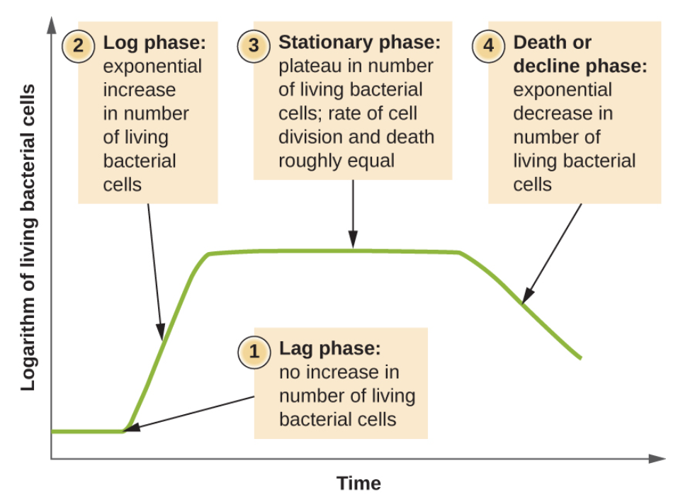

Figure 1. The growth curve is represented by this logarithm of living bacterial cells over a period of time. The 4 distinct phases of a bacterial growth curve (lag, log, stationary and death phases) are shown in this figure.

Survival and Enumeration:

Enumeration refers to the number of organisms that are growing in a sample, which involves small dilutions and large number of cells. The growth of microorganisms is determined by their number under various conditions. In some enumeration methods, the sample, which represents a 10⁰ dilution, is diluted in a 10-fold dilutions before enumeration and “to enumerate the bacteria, 0.1 ml from each dilution tube is plated on an agar plate of purpose medium” (Montville et al., 2012, p.16). The colonies are counted after incubation time and the number is multiplied by the dilution factor. The Most Probable Number (MPN) and Colony Forming Units (CFU) are used to determine the number of viable microorganisms in the sample tested. MPN is used for liquid broth and CFU is used for solid agar samples. MPN differs from CFU because it is an estimation method, less precise, estimates viable numbers of microorganisms in 10-fold dilutions as well as works “only when low levels (<30 CFU/ml) are present (Montville et al., 2012, p.16). On the other hand, CFUs are more precise and the results are based on the number of colonies. The plate count method identified the number of organisms that are able to grow on a given medium after incubation.
Understanding the different intrinsic and extrinsic factors that are affecting the microbial growth in various foods helps food scientist and microbiologists reduce food contamination as well as the survival chances of microorganisms, such as yeasts, mold and bacteria. The growth of microorganisms is influenced by factors like temperature, oxygen, moisture and pH; therefore, controlling these factors reduces food spoilage, transmission of diseases and unwanted microbial contamination.

Extrinsic and Intrinsic Factors that Effect Growth, Microbial Antagonism, Quorum Sensing
Picture foods as the environment that bacteria live in. There are internal (intrinsic) factors and external (extrinsic) factors that affect the growth of microorganisms in food. Intrinsic factors include pH, presence and availability of water, pH, physical structure, oxidation-reduction potential, and more. Extrinsic factors include temperature, humidity, atmosphere, and more. The lower the pH the more acidic the internal environment and the more energy the cell must dedicate to neutralizing it. Thus, the cell has less energy to grow and produce toxins. In fact, most microorganisms cannot grow in conditions lower than pH of 4.4 and those that can are typically spoilage organisms such as fungi. Upper limit for foodborne pathogen growth is about 8 or 9 pH. pH also influences gene expression. Since charged organic compounds cannot pass through the cellular membrane, they acidify the cytoplasm. This change in intracellular pH affects the proton gradient and can denature proteins.
Further on, there are a few ways in which microorganisms can combat this. Salmonella, for example, can increase the activity of their proton pumps, thereby actively pumping H+ protons out of the cell to neutralize the cytoplasm. Water activity is another major intrinsic factor that can affect growth. Water activity is the amount of water that is readily available for the microorganism. The lower the water activity, the lower the available water, the lower the growth. Some microorganisms prefer high osmotic pressure (osmophilic) whilst others prefer low water activity (xerophilic). Extrinsic factors are external factors, factors from the environment, that affect microbial growth. Decreased temperatures slow microbial growth whereas high temperatures might denature proteins. Thus, microorganisms have a specific temperature at which growth is optimized. Not only does temperature affect growth but it also impacts what genes are expressed and virulence of certain diseases. For example, the Y. enterocolitica bacteria’s processes are optimized between 22-37 degrees. The bacteria is nearly undetectable at four degrees (Matthews et. al., 2019, p. 33-34; Food, 2021).
The intrinsic and extrinsic factors are what control the homeostatic environment (both internally and externally) of the microorganism. Thus, through the manipulation of said factors, environments can be controlled. Thereby speeding up food spoilage or slowing it down via preservation processes. Food microbiology is concerned with all phases of microbial growth (lag, exponential, stationary, and death) described above. Food preservation processes work to increase the lag time, decrease the growth rate, decrease the stationary phase, and increase the death rate (Matthews et. al., 2019, p. 40). This can be accomplished via refrigeration: decreasing the temperature is an extrinsic factor that slows organism growth. Reducing water availability, through drying processes, decreases the water activity - a major intrinsic factor leading to cell growth. Canning is a process by which heated food is sealed in specialized containers. This process kills microbes, inhibits growth, increases acidity levels (sometimes), and prevents spoilage. Pasteurization, mentioned earlier, super heats milk and other liquids, thereby killing pathogens and preventing spoilage. Foods can also be preserved chemically. The use of propionic acid in cakes prevents the growth of mold. Radiation has been used on food-handling equipment to kill off microbes that might be present and unseen to the naked eye. Gamma radiation is often used to extend the shelf life/sterilize meat products and seafoods (Food, 2021; Matthews et. al., 2019, p. 40).
The downside to certain preservation techniques is that they pick one aspect that manipulates the internal or external environment and take it to the extreme. This can result in harsh, physical processing that can change the taste of food - such as pickling. Thus, research has delved into numerous other paths that might continue to preserve food, whilst avoiding the drawbacks of certain extreme preservation techniques. These hurdles include both internal and external factors and results in the mild preservation of foods. Thus, this is typically done on fresh foods that can be sold quickly. For example, throw high temperatures during processing, low temperatures during storage, low water activity, low pH levels, and chemical preservatives in the product can force a microorganism to “jump” these “hurdles,” but the idea is that the microorganism can jump some but not all. This is how salami-type fermented sausage is made. In the early stage of the ripening process, salt and nitrite are introduced, which inhibit bacteria present in the batter. During the long ripening process, pH is increased, and water availability is decreased. It is through the gradual decrease of available water that the most impact can be seen (Leistner & Gorris, 1995, p. 43).

Another technique that does not require the “chemical sanitizer and harsh, physical processing intervention strategies,” includes the use of microbial antagonisms. Microbial antagonists are bacteria that are antagonistic to pathogens on specific foods. For example, lactic acid bacteria (LAB) that produce Lactobacillus casei, Lactobacillus plantarum, and Pediococcus spp., were found to inhibit the growth of Salmonella, Aeromanas, and Listeria in salad (Kostrzynska & Bachand, 2006, p. 1018). Returning to the example regarding fermented sausage, certain pathogens, such as E. coli, can survive the fermentation process, and Listeria has been found to survive the extreme conditions of the manufacturing process. Outbreaks caused by E. coli and Listeria in fermented sausage were seen in Canada in 1999 and 1998 and in the United States in 1994. Studies have shown that introducing bacteriocin-producing LAB strains were able to inhibit certain strains of Listeria found in fermented sausage - work is still being done to develop LABs that attack E. coli. Research is still being done to understand the full antimicrobial effects these microbial antagonists might have (Kostrzynska & Bachand, 2006, p. 1024).

Intrinsic and Extrinsic Factors Affecting Microbial Growth in varying Foods:

Intrinsic factors are characteristics that influence the microbial growth in foods. Extrinsic factors refer to the external elements that influence microbial growth in foods, such as gas composition and temperature. Below are three extrinsic and three intrinsic factors that will be discussion in greater detail in this paper:

Intrinsic Factors:
- pH – pH is a measurement of the acidity in foods. The pH is measured on a scale of 0 to 14. A measurement of 0 is means the food is very acidic, 7 means it is neutral and 14 means that the food is very basic, with each unit representing a 10-fold difference. Microorganisms may grow in food as a result of the changes in pH. For instance, growth of C. botulinum is stimulated when the pH is raised as a result of growth of molds in high acid foods. It’s important to note that “in their natural state, most foods such as meat, fish, and vegetables are slightly acidic while most fruits are moderately acidic” and there is a pH optimum, minimum, and maximum for microbes to grow in foods. Since many microbes cannot grow below pH 4.4, microbial issues in foods with pH values of <3.0 are rare (Montville et al., 2012). Another important aspect of pH is that it influences the lethality of heat treatment, gene expression as well as the buffering capacity of different foods. Acidity in cells is changed through several mechanisms, which are organic acids, transmembrane proton gradient and “the protonation or deprotonation of amino acids of proteins (Montville et al., 2012, p.26). Neutrophiles, such as Escherichia coli, tend to thrive between pH 6.6 and 7.5. For instance, the pH of milk is around 6.5 but becomes more acidic as the milk gets sour and bacteria start converting lactose to lactic acid.

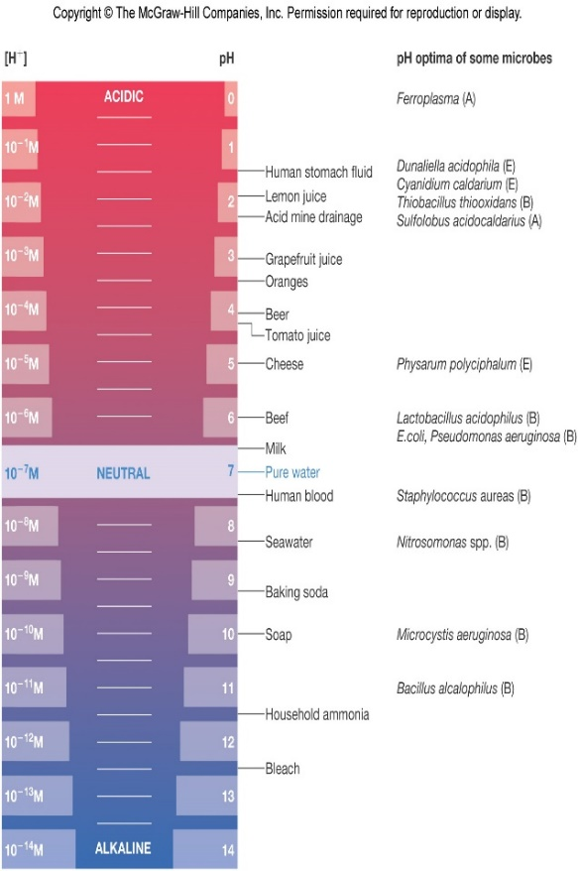

Figure 2. The above pH scale shows the optima for different organisms and well as the pH for different foods and household items. Many microorganisms change the pH of their environment by producing waste products that make it basic or acidic.

- Water activity – Water activity is a major element that microorganisms need to grow in foods. Water activity is the “ratio of water vapor pressure of the food substrate to the vapor pressure of pure water at the same temperature where p = vapor pressure of the solution and po = vapor pressure of the solvent (usually water)” (Anonymous, 2001). The water is bound by hydrogen bonding and ionic interactions that influence that chemical reactions in food can result in microbial growth based on the amount of unbound or available water present. Low water activity is an indicator that most of the water is bound. Osmotolerant bacteria, such as Staphlococcus aures, can grow over wide ranges of water activity (Singh, 2021). Microbial growth is generally inhibited in dry environments because microorganisms rely of moisture to multiply. In the food industry, it is crucial that the water activity in foods is controlled to prevent spoilage and the rates of chemical reactions as well as ensure that food is safe for human consumption. Freezing, drying and adding salt/sugar are ways to control water activity in foods. Some regulations (21 CFR 113.3(e) (1) (ii)) indicate that “sterility can be achieved by the control of water activity and the application of heat” and destroy vegetative cells in microorganisms, such as staphylococci (FDA, 2014). Low-acid canned foods with water activity greater than 0.85 such as toppings, puddings, guava paste and salted vegetables, are examples food that is preserved due to controlling the water activity (FDA, 2014).

Nutrient content – Microorganisms depend on nutrients as a source of survival, maintenance and growth in foods. Some of the essential nutrients that microbes require to replicate are water, vitamins, oxygen and carbon. Different microbes require different amounts, types and sources of nutrients to multiply and create energy. Eggs and milk products are a great source for microbial growth because they are rich in nutrients, which play a vital role in the bacterial growth rate, spoilage as well as available energy that microorganisms need. Microorganisms use fats, carbohydrates, alcohols, minerals, sugars, amino acids and more to obtain energy. For instance, gram positive bacteria, such as S. aureus, are “more fastidious in their nutritional requirements and thus are not able to synthesize certain nutrients required for growth” (Anonymous, 2001). The essential nutrients that are available determine the rate of growth for the microorganisms and which ones will survive since different microorganisms have specific nutrient requirements. Salmonella Enteritidis needs iron to grow and cause food spoilage in foods, such as eggs, therefore, the chances of spoilage can be lowered if there is limited amount of iron available to the microbes (Anonymous, 2001).

Extrinsic Factors:
- Temperature – The influence of temperature on gene expression, growth rate and physiology is extremely significant because it “regulates the expression of genes governing traits ranging from motility to virulence” (Montville et al., 2012, p.32). For instance, temperature regulates L. monocytogenes’ expression of genes. Since microbes are unable to regulate their internal temperature, there are techniques designed to disturb their internal environment to preserve the food and prevent microbial growth. Microbes and their spores can be inhibited if the temperature is controlled in foods. The temperature range for microbial growth is broad with an optimum, minimum and maximum. For example, the growth range is 0º C to 20º C for psychrophiles, 0º C to 35º C for psychrotrophs, 20º C to 45º C for mesophiles, 55º C to 85º C for thermophiles and 85º C to 113º C for hyperthermophiles (Singh, 2021). Since temperature control is a key factor for food safety, it’s important to keep foods below 40º F or 140º F, depending if they’re cold or hot, because this range is favorable for microorganisms. This temperature abuse zone can cause microbes to rapidly multiples if improper cooling and heating are selected. The microbes’ thermal sensitivity is also affected by temperature. Heat is the most effective and practical method to denature the enzymes and destroy microorganisms before they cause any harm. The microbe’s thermal sensitivity is also affected by temperature. Cheese and seafood are two examples of foods that are affected by this extrinsic factor in microbial growth of microorganisms.

- Time – Time is very significant factor in microbial growth and can be manipulated to control the number of microorganisms produced and keep the food safe. This factor determines and influences the growth rate, lag time, and the type of microorganisms that can grow in the food. The microbial growth curve, which consists of the lag, log, stationary and death phases, relies on time to determine how food safety can be achieved and manipulated. In the food industry, time is one of the main factors that product developers consider to determine the products’ shelf life, which is a reasonable period of time for consumption of the perishable food product. Time control during processing, handling, storage and distribution assures consumer protection from illness by pathogenic microorganisms in foods. Time control is determined by the potential for subsequent growth of microbes and contamination with pathogenic bacteria of concern (Anonymous, 2001). Controlling the time makes food preservation, safety, quality and storage an easier/safer process.

- Growth– Factors, such as accumulation of metabolic products, influence the growth of microorganisms. Harmful microbes like Salmonella enterica and Listeria monocytogenes are controlled by numerous practices, such as refrigeration, which prevents illnesses and reduces their growth rate. Understanding microbial growth helps us maintain balanced interactions and establish principles with these microorganisms.

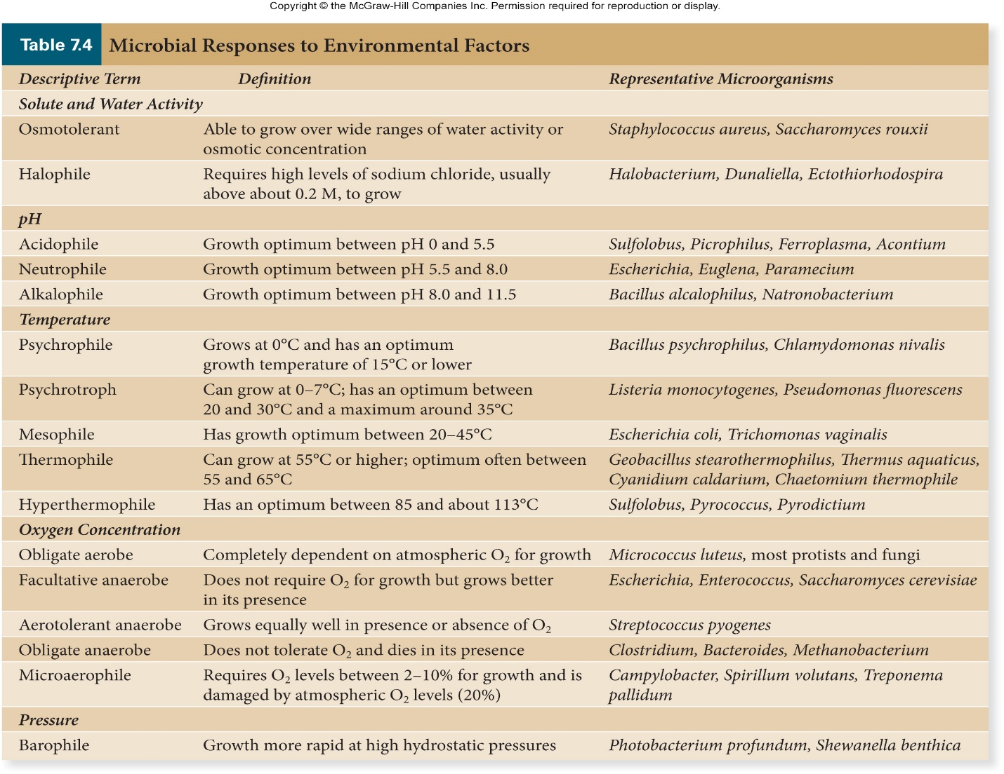

Figure 3. The environmental factors play a big role in microbial growth and their survival abilities in harsh conditions.

Cell Stress, Sub-lethal cell damage affecting culturing ability of the cell:
Cell stress is a defense mechanism used by the cell to encounter internal and external stresses that target it and affect its culturing ability. The cell stress is sometimes caused by biological, chemical, physical, infectious, microbial or nutritional factors. Based on the severity of the stress, the cell engages in various strategies to encounter the stresses by sensing the damage and selecting the appropriate pathways to repair, reprogram or die. The Cell injury is the “inability of cells exposed to the sublethal stress to grow on selective media, while retaining capturability on nonselective media” and “sublethal levels of heat, radiation, acid, or sanitizers may injure rather than kill cells” (Montville et al., 2012, p.19). Cells can be injured by different ways, such as freezing and heating which can damage the membrane of the cell. Environmental factors, time, selective-agent concentration and temperature affect the rate and extent of the repair process that cells undergo.

So why continue research into food preservation techniques if science has already developed an arsenal? Foodborne outbreaks are on the rise in industrialized nations, specifically as the demand for fresh and organic foods is on the rise. The discovery of viruses and bacteria that cause foodborne illnesses is a recent development and, as a result, science might only know about 1% of them. Microorganisms also continue to change. Adaptation to current preservation techniques and production methodologies has led to the development of resistant strains that can survive in harsh conditions. Cells have managed to adapt via techniques such as signal transduction and biofilm formation. Signal transduction can result in cells turning on or off specific genes, influence enzymatic activity, or expression of phenotypes under stress. The formation of biofilms, aggregation of cells into complex structures on solid surfaces, has led to resistance of heat, chemicals, and sanitizers. Although, biofilms are still not well understood.
Then, another method that might play a role in food spoilage is quorum sensing (QS). Quorum sensing is a colonies’ ability to detect if their population is big enough to justify action/change. In large colonies, bacteria secrete signal molecules to nearby bacteria. When the signal molecule is absorbed into the cell, it binds to an intracellular regulator protein that affects transcription of a specific gene and elicits a cellular response. It is questionable whether QS is involved in food spoilage - as there is little evidence available to support this. E. coli O157:H7, for example, emits a bioluminescence response in Vibrio harveyi. Probiotic bacteria prevent E. coli infection in mice- by potentially interrupting QS - whereas vacuum-packed meat inoculated with QS inhibitors did not influence food spoilage. Thus, the results are mixed, and there is no definitive answer as to QS’s impact on food spoilage (Matthews et al., 2019, p. 24-27; Food, 2021; Havelaar et al., 2010).
Finally, an increase in global food trade has changed the system, resulting in a need for worldwide food regulation and long-term preservation techniques. Also, with the rise in Globalization comes a strain on the world food system. Famine, foodborne pathogen outbreaks, the introduction of toxic compounds, food safety risks, and much more are becoming ever more important factors for Food Microbiologists to take into consideration. Thus, future advancements in Food Microbiology are aimed at preparing for the rise of new disease sources, new pathways of spreading, and new drivers that make certain populations more susceptible. Science is preparing for future disasters such as climate change antimicrobial resistance, war, and foodborne illness outbreaks (Havelaar et al., 2010). Food Microbiology had a very slow advancement over thousands of years, but there is still much that is unknown. The future of Food Microbiology now lies in how it will tackle microorganisms on a global scale.

Quorum Sensing
Quorum sensing is the communication occurring between bacterial cells via production, detection, and responses to extracellular signaling molecules called autoinducers. It involves both interspecies and intraspecies communications, and can be used for synergy or antagonism. With a few exceptions, Gram (-) bacteria use acylated homoserine lactones as autoinducers, and Gram (+) bacteria use peptides. It occurs in the following steps.
- Autoinducers are produced. At low densities, there is little to no detection or response. Over time, autoinducers diffuse away.
- As the colony size increases, the number of autoinducers increases. At higher densities, the autoinducers are detected by cytoplasmic or membranous receptors.
- Responses are initiated. Responses occur as alterations in gene expression, with results such as sporulation, antibiotic production, biofilm formation, virulence factor secretions, and more.
- Autoinducers use feed-forward mechanisms, where detection of autoinducers results in the increased production of autoinducers, creating an exponential reaction chain.
Quorum Sensing for Synergy
As previously mentioned, quorum sensing can be used for synergy. An example is spoilage bacteria Pseudomonas syncyanea and Lactococcus lactis, which thrive together, and create a unique blue pigment in milk, but only when together.
Quorum Sensing for Offense
More often quorum sensing is used for microbial antagonism, as species fight for shared resources. Reactions can be defensive but typically are offensive, like the production of acids or specific antimicrobials to attack a species with similar needs. Microbes may even stockpile nutrients and/or release chelating compounds with the purpose of leaving other species unable to obtain their essentials.
Quorum Sensing for Defense
An example of a quorum sensing being used as a defense mechanism is in the expression of virulence factors. At low concentrations, bacterial cells typically do not produce pathogenic compounds, knowing that they will trigger the host’s defenses and become compromised. At higher concentrations, the cells can activate their virulence genes and have the numbers to potentially overpower the host cells.
Quorum Sensing for Metabiosis
In essence, metabiosis is an interspecies feed-forward synergy. The growth of one species creates a byproduct which in turn encourages the growth of a second species, which produces a different byproduct encouraging the growth of a third species; this may continue many times over. An example of this is in raw milk, when Lactococcus lactis produces lactic acid, which lowers the pH encouraging growth of other lactobacilli. Oxidative yeasts and molds can then use the lactic acid to grow, and in doing so raise the pH of the milk. The higher pH will allow for the growth of proteolytic bacteria.

Microbial Food Spoilage:
Microbial food spoilage takes place due to the growth of microorganisms, which includes “prokaryotes (bacteria), single-celled organisms lacking defined nuclei and other organelles, and eukaryotes, single-celled (yeasts) and multicellular (molds) organisms with nuclei and other organelles”. These microorganisms produce substances in the food that change the color, texture, flavor, consistency or smell of the food and make it unacceptable for consumption. The major causes of food spoilage are physical, chemical and microbial.This is a process of change of the chemical and physical properties that lead to the food becoming undesirable and unfit for human consumption. Many natural foods, such as fish, milk and meat, have a short shelf life and can spoil easily. Microbial food spoilage is inevitable and may be the result of variety of factors like temperature, moisture, endogenous enzymes, parasites as well as oxygen levels. Most food spoilage occurs on the surface of the food and the “food is generally considered spoiled when the bacterial counts exceed 10⁶ or 10⁷. This is 1,000,000 to 10,000,000 bacteria per gram”. The six conditions that affect the growth of the bacteria are the type of food, acidity, time, moisture, oxygen and temperature. Bacterial growth is promoted by starch, moisture and high protein. This is discussed in more details in the intrinsic and extrinsic factors sections.

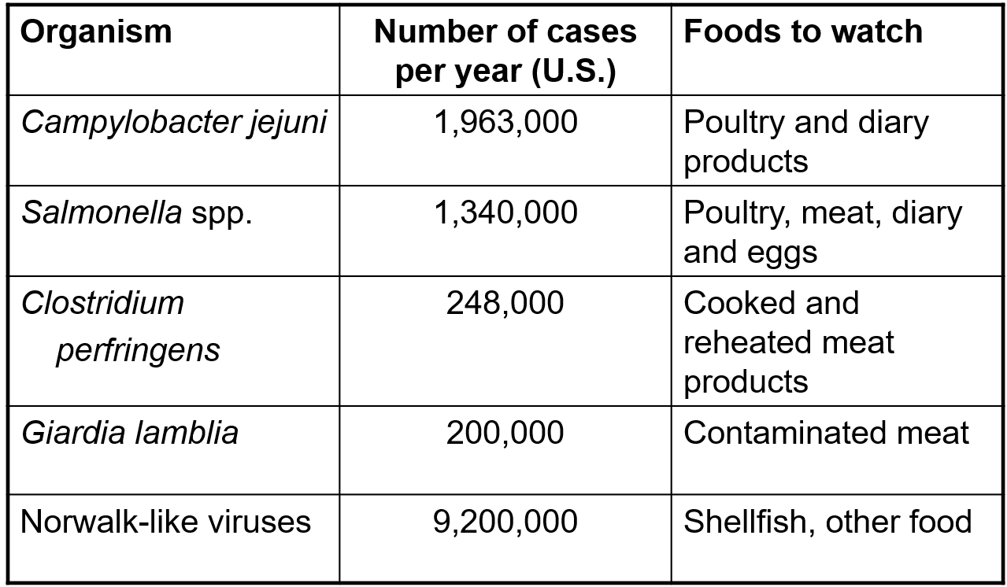

Bibliography

Aneja, K. R., Dhiman, R., Aggarwal, N. K., & Aneja, A. (2014). Emerging Preservation Techniques for Controlling Spoilage and Pathogenic Microorganisms in Fruit Juices. International Journal of Microbiology, 2014, 1-14. doi:10.1155/2014/758942
Borresen, E. C., Henderson, A. J., Kumar, A., Weir, T. L., & Ryan, E. P. (2012). Fermented Foods: Patented Approaches and Formulations for Nutritional Supplementation and Health Promotion. Recent Patents on Food, Nutrition & Agriculturee, 4(2), 134-140. Doi: 10.2174/2212798411204020134
Bourdichon, F., Casaregola, S., Farrokh, C., Frisvad, J. C., Gerds, M. L., Hammes, W. P., . . .
Hansen, E. B. (2012). Food fermentations: Microorganisms with technological beneficial use. International Journal of Food Microbiology, 154(3), 87-97. doi:10.1016/j.ijfoodmicro.2011.12.030
Buchholz, K., & Collins, J. (2013). The roots—a short history of industrial microbiology and biotechnology. Applied Microbiology and Biotechnology, 97(9), 3747-3762. doi:10.1007/s00253-013-4768-2
Havelaar, A. H., Brul, S., de Jong, A., de Jonge, R., Zwietering, M. H., & Ter Kuile, B. H. (2010). Future challenges to microbial food safety. International journal of food microbiology, 139 Suppl 1, S79–S94. Doi: 10.1016/j.ijfoodmicro.2009.10.015
Kostrzynska, M., & Bachand, A. (2006). Use of microbial antagonism to reduce pathogen levels on produce and meat products: A review. Canadian Journal of Microbiology, 52(11), 1017-1026. doi:10.1139/w06-058
Ledenbach, L. H., & Marshall, R. T. (2009). Microbiological Spoilage of Dairy Products.
Compendium of the Microbiological Spoilage of Foods and Beverages, 41-67. doi:10.1007/978-1-4419-0826-1_2
Leistner, L., & Gorris, G. M. (1995). Principles and applications of hurdle technology. New Methods of Food Preservation, 1-21. doi:10.1007/978-1-4615-2105-1_1
Matthews, K. R., Kniel, K. E., & Montville, T. J. (2019). Food microbiology: An introduction. Washington, DC: ASM Press.
Obladen, M. (2014). From Swill Milk to Certified Milk: Progress in Cow’s Milk Quality in the 19th Century. Annals of Nutrition and Metabolism, 64(1), 80-87.
Opal S. M. (2009). A Brief History of Microbiology and Immunology. Vaccines: A Biography, 31–56. https://doi.org/10.1007/978-1-4419-1108-7_3
Riedel S. (2005). Edward Jenner and the history of smallpox and vaccination. Proceedings (Baylor University. Medical Center), 18(1), 21–25. Doi:10.1080/08998280.2005.11928028
Singh, Om (2021). Basics of microbiology [Powerpoint]. Blackboard. Retrieved from https://blackboard.jhu.edu/webapps/blackboard/content/listContent.jsp? course_id=_224136_1&content_id=_9152752_1
Singh, Om (2021). Food spoilage and pathogenic bacteria [Powerpoint]. Blackboard. Retrieved from https://blackboard.jhu.edu/webapps/blackboard/execute/content/file? cmd=view&content_id=_9152791_1&course_id=_224136_1&framesetWrapped=true

